**Task 1**

**VR Website Footer Section**

In this assignment, let's build a VR Website Footer Section by applying the concepts we learned till now.

**Refer to the below images.**

The following images illustrate all device sizes, from extra small to extra large.

Extra Small (Size < 576px) and Small (Size >= 576px):

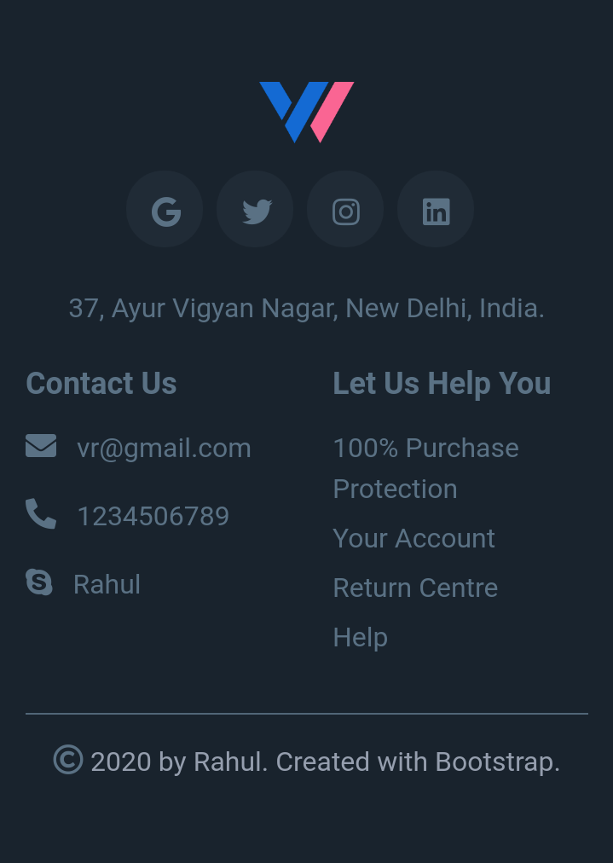

Medium (Size >= 768px), Large (Size >= 992px) and Extra Large (Size >= 1200px):

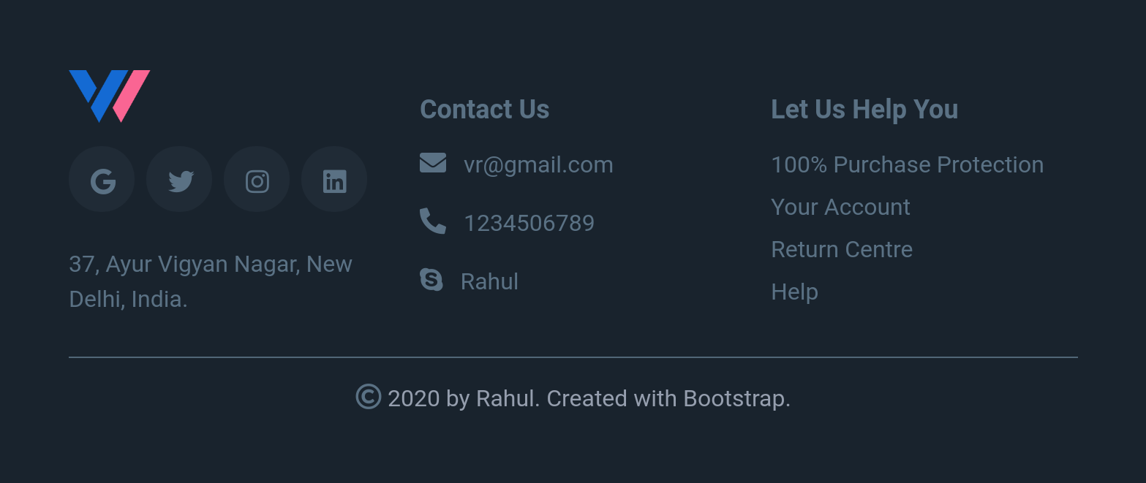

**Resources**

Use the image URL given below.

* https://d1tgh8fmlzexmh.cloudfront.net/ccbp-responsive-website/vr-logo-img.png

**CSS Colors used:**

#5a7184

#959ead

#19232d

#202b36

**Task 2**

**Portfolio Website Navbar & Banner Section**

In this assignment, let's build a Portfolio Website Navbar & Banner Section by applying the concepts we learned till now.

**Refer to the below images.**

The following images illustrate all device sizes, from extra small to extra large.

Extra Small (Size < 576px) and Small (Size >= 576px):

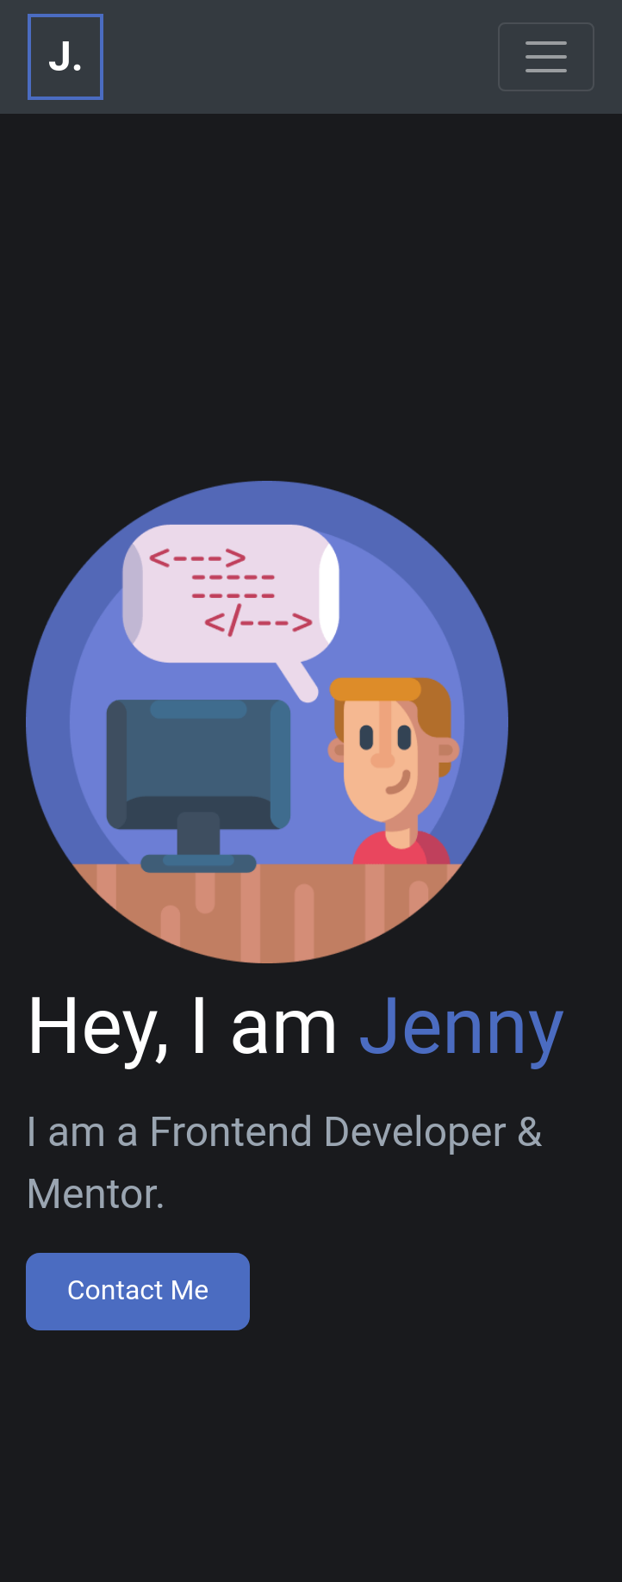

Medium (Size >= 768px):

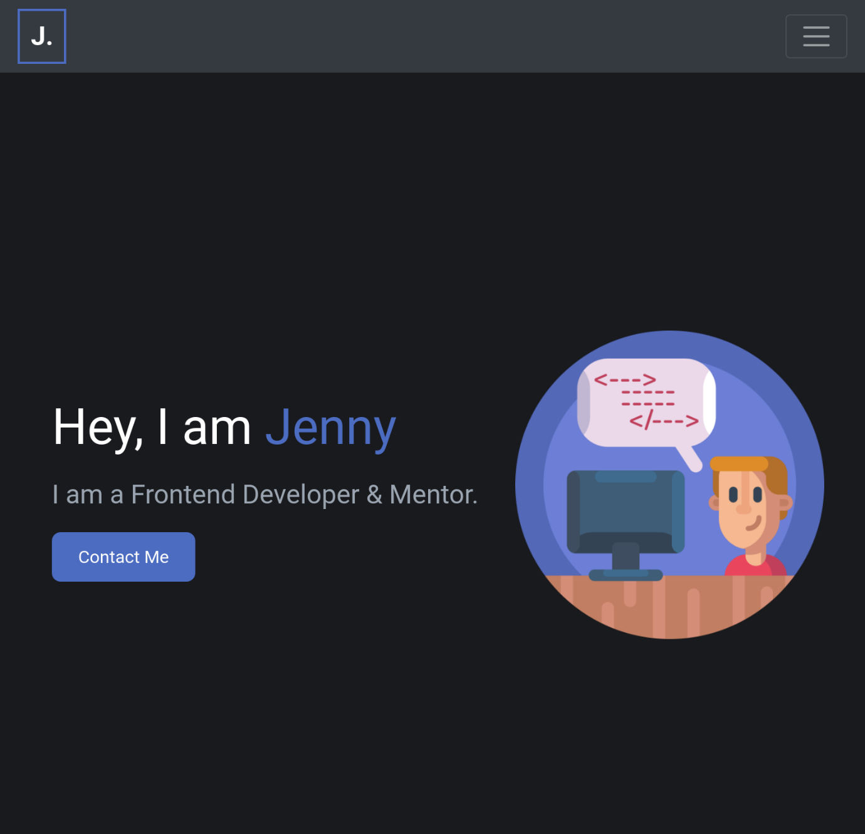

Large (Size >= 992px) and Extra Large (Size >= 1200px):

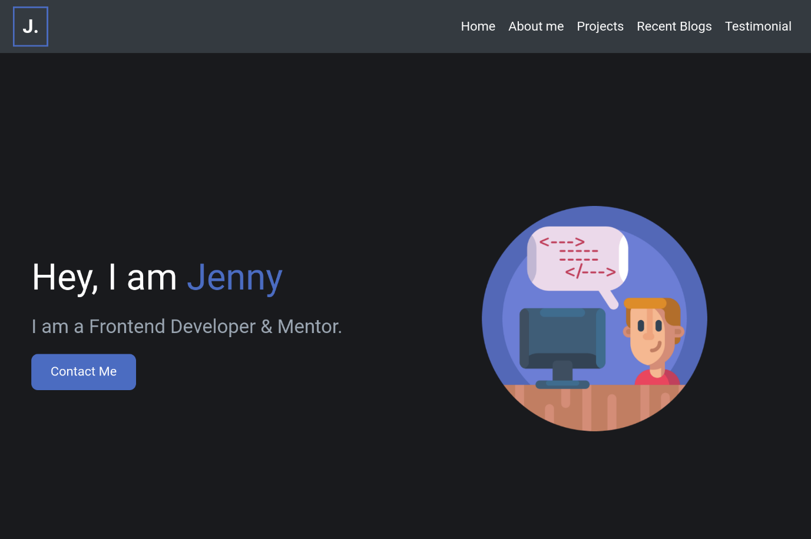

#### Resources

Use the image URL given below.

* https://d1tgh8fmlzexmh.cloudfront.net/ccbp-responsive-website/portfolio-banner-img.png

**CSS Colors used:**

#4b6cc1

#191a1d

#9aa5b1

**Task 3**

**Portfolio Website About Me & Skills Sections**

In this assignment, let's build a Portfolio Website About Me & Skills Sections by applying the concepts we learned till now.

**Refer to the below images.**

The following images illustrate all device sizes, from extra small to extra large.Extra Small (Size < 576px) and Small (Size >= 576px):

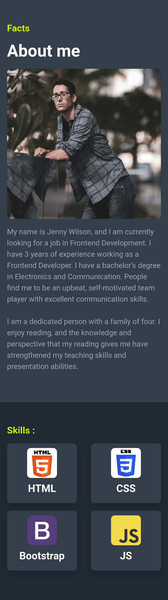

Medium (Size >= 768px), Large (Size >= 992px) and Extra Large (Size >= 1200px):

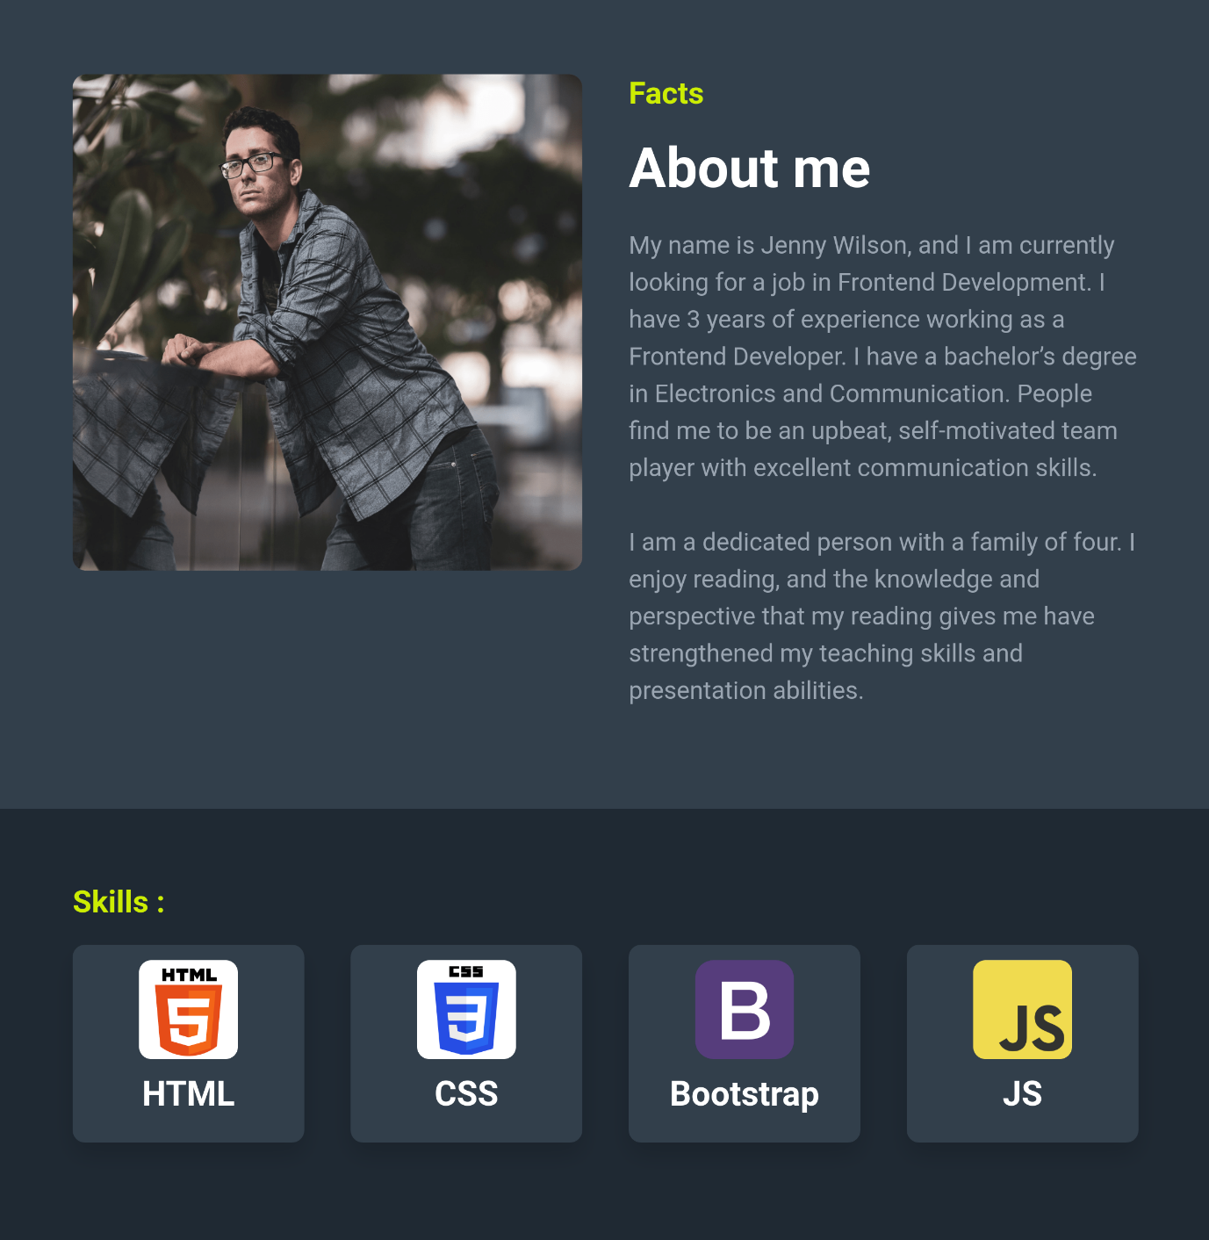

**Resources**

Use the image URLs given below.

* https://d1tgh8fmlzexmh.cloudfront.net/ccbp-responsive-website/portfolio-about-me-img.png
* https://d1tgh8fmlzexmh.cloudfront.net/ccbp-responsive-website/portfolio-skills-html-img.png
* https://d1tgh8fmlzexmh.cloudfront.net/ccbp-responsive-website/portfolio-skills-css-img.png
* https://d1tgh8fmlzexmh.cloudfront.net/ccbp-responsive-website/portfolio-skills-bootstrap-img.png
* https://d1tgh8fmlzexmh.cloudfront.net/ccbp-responsive-website/portfolio-skills-js-img.png

**CSS Colors used:**

#cced00

#1f2933

#9aa5b1

#323f4b

**Task 4**

**Portfolio Website Projects Section**

In this assignment, let's build a Portfolio Website Projects Section by applying the concepts we learned till now.

**Refer to the below images.**

The following images illustrate all device sizes, from extra small to extra large.

Extra Small (Size < 576px) and Small (Size >= 576px):

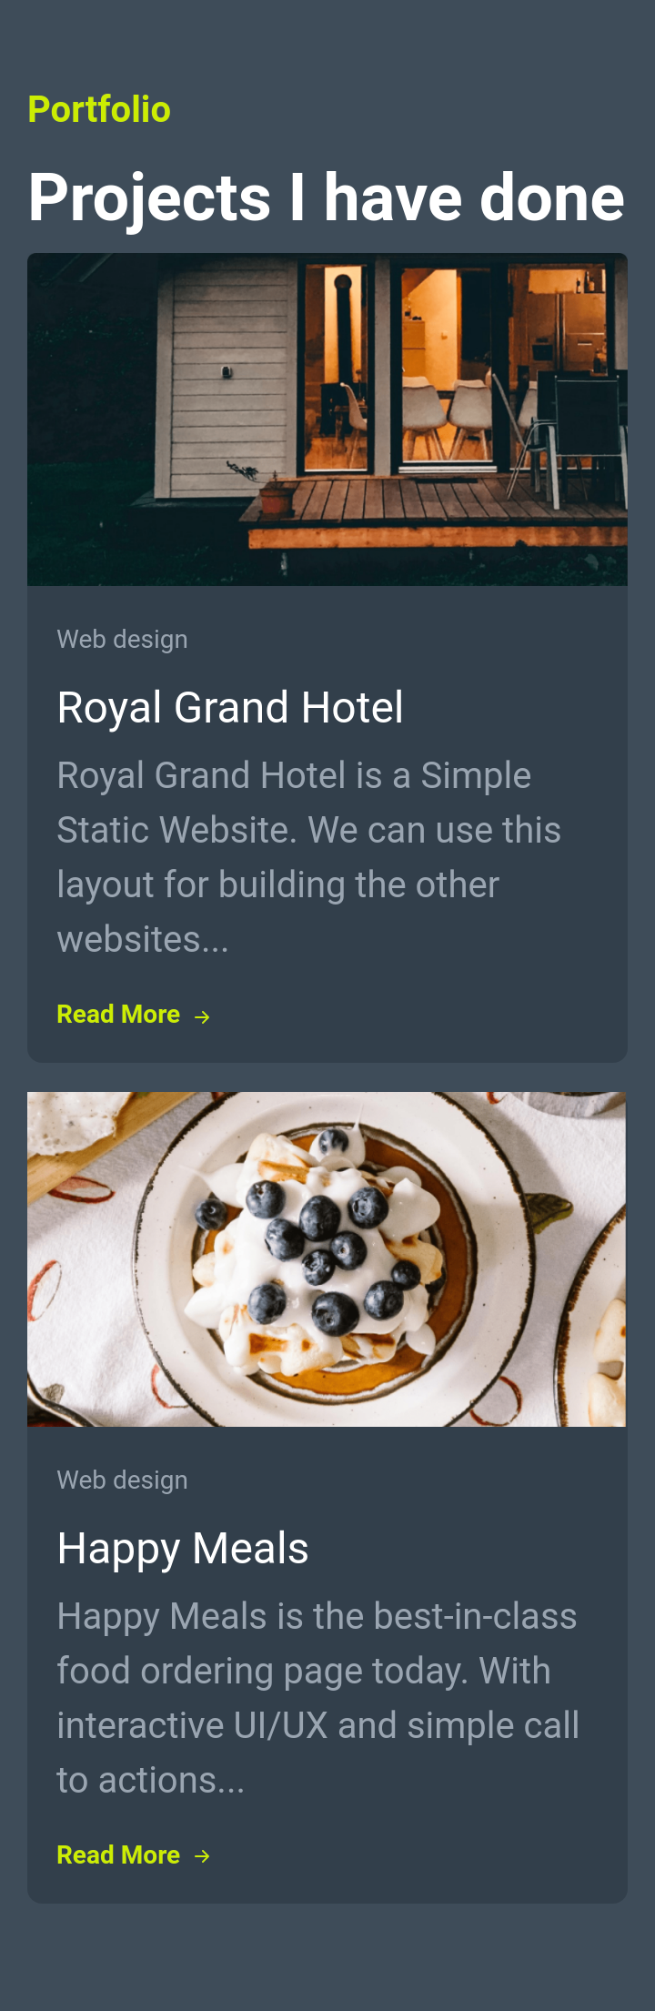

Medium (Size >= 768px), Large (Size >= 992px) and Extra Large (Size >= 1200px):

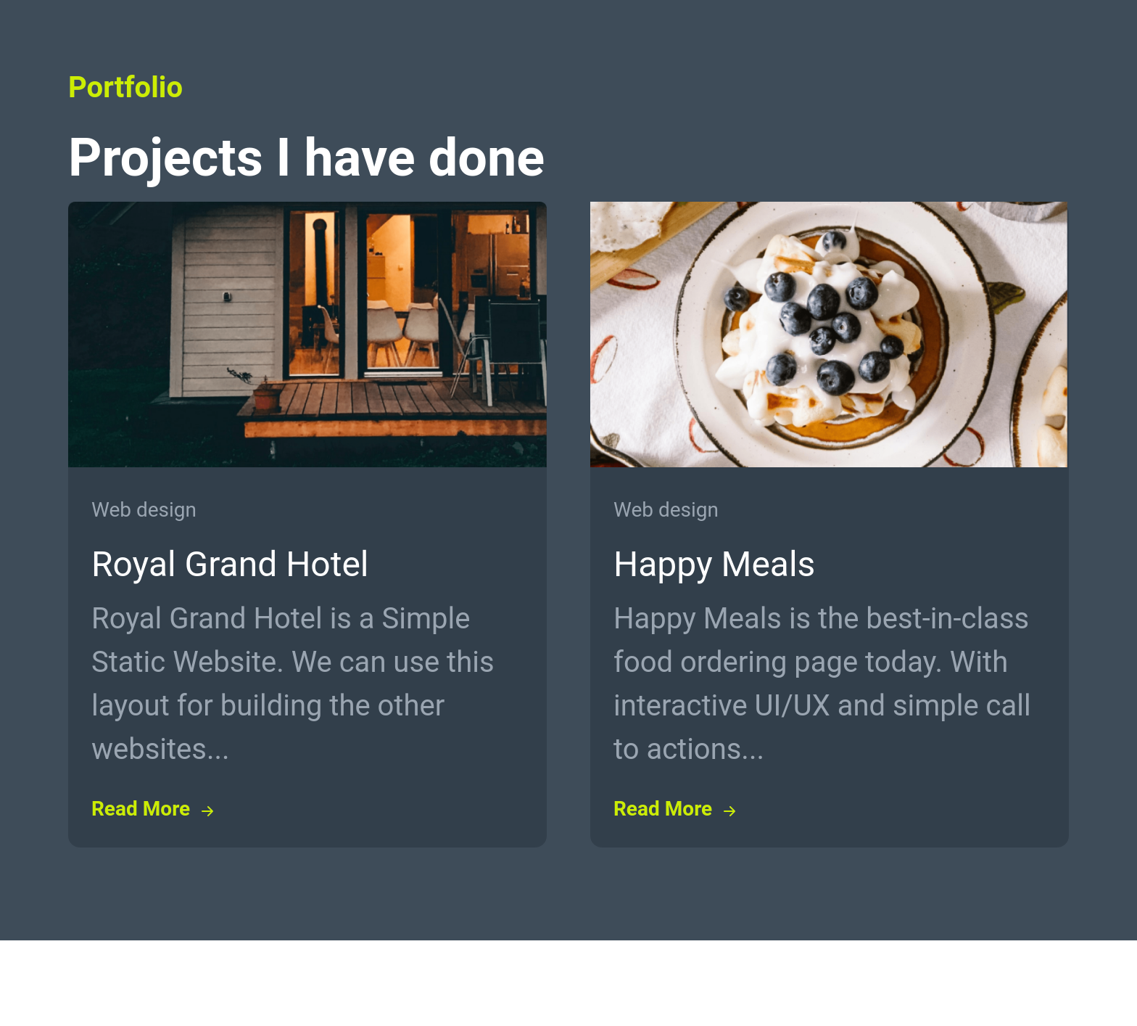

**Resources**

Use the image URL given below.

* https://d1tgh8fmlzexmh.cloudfront.net/ccbp-responsive-website/portfolio-project-1-img.png
* https://d1tgh8fmlzexmh.cloudfront.net/ccbp-responsive-website/portfolio-project-2-img.png

**CSS Colors used:**

#cced00

#3e4c59

#9aa5b1

#323f4b

**Task 5**

**Portfolio Website Services Section**

In this assignment, let's build a Portfolio Website Services Section by applying the concepts we learned till now.

**Refer to the below images.**

The following images illustrate all device sizes, from extra small to extra large.

Extra Small (Size < 576px) and Small (Size >= 576px):

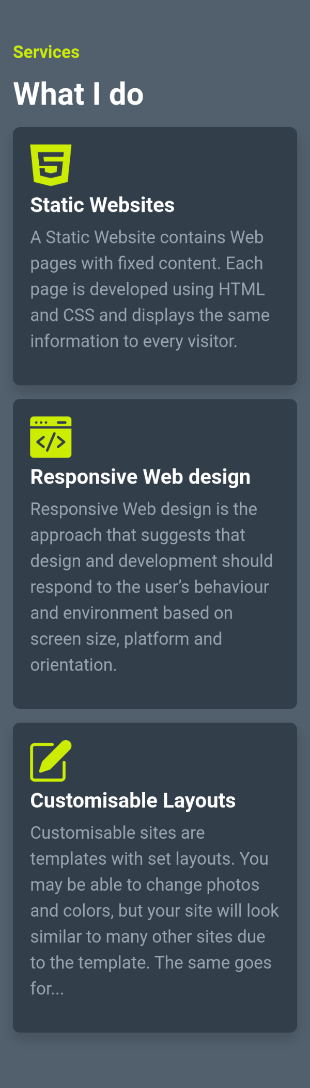

Medium (Size >= 768px):

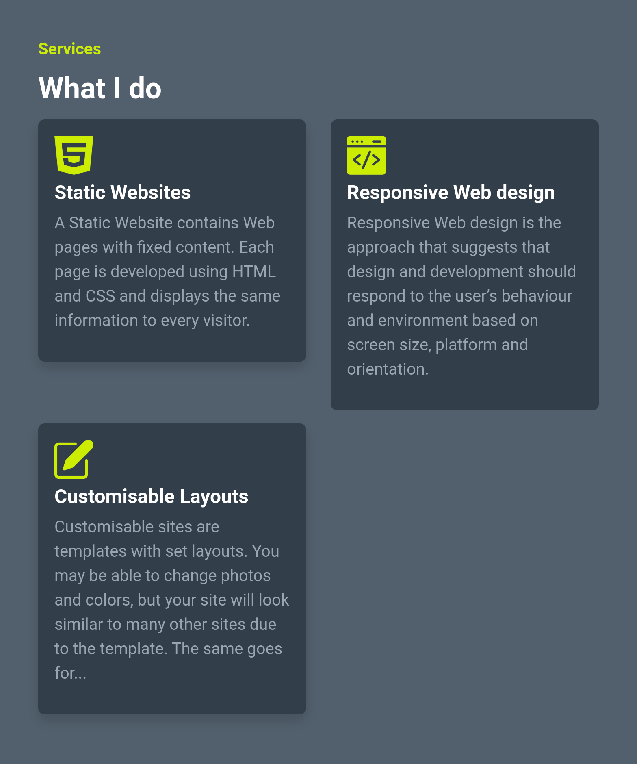

Large (Size >= 992px) and Extra Large (Size >= 1200px):

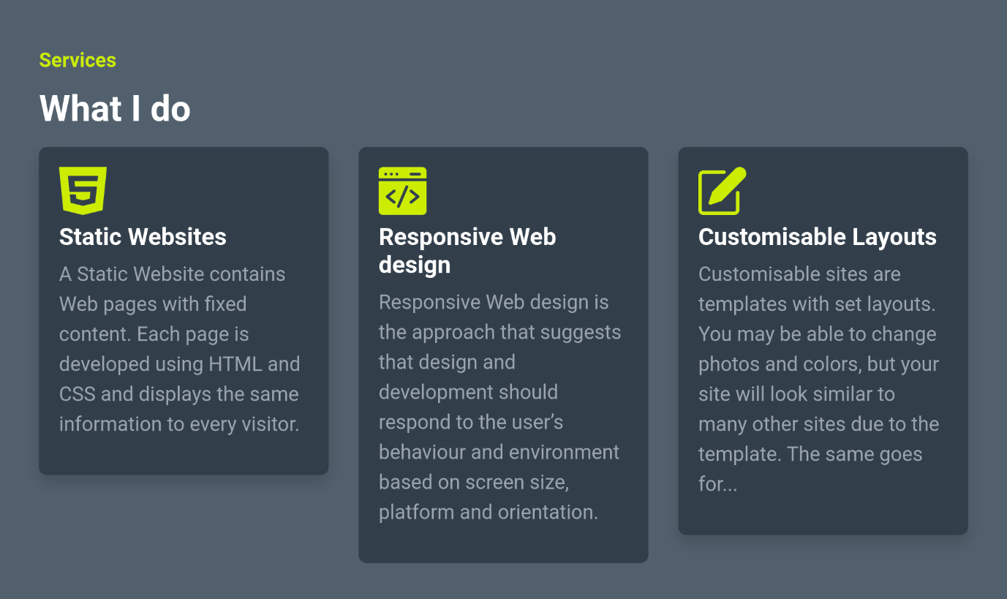

**Note**

**Try to achieve the design as close as possible.**

**Resources**

Use the image URLs given below.

* https://d1tgh8fmlzexmh.cloudfront.net/ccbp-responsive-website/portfolio-web-design-img.png
* https://d1tgh8fmlzexmh.cloudfront.net/ccbp-responsive-website/portfolio-web-development-img.png
* https://d1tgh8fmlzexmh.cloudfront.net/ccbp-responsive-website/portfolio-customize-img.png

**CSS Colors used:**

#cced00

#52606d

#9aa5b1

#323f4b

**Task 6**

**Portfolio Website Work Done Section**

In this assignment, let's build a Portfolio Website Work Done Section by applying the concepts we learned till now.

**Refer to the below images.**

The following images illustrate all device sizes, from extra small to extra large.

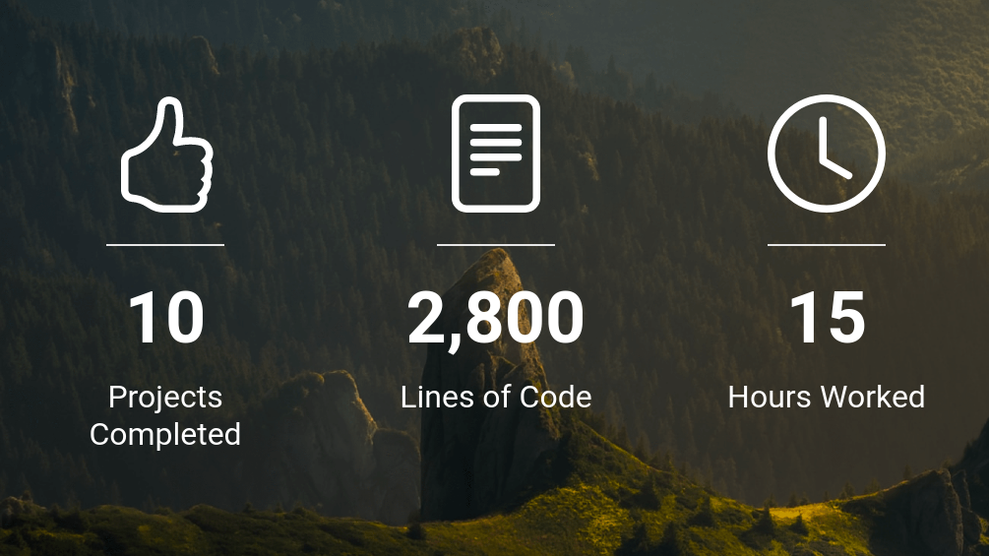

Note

* Try to achieve the design as close as possible.
* The Icons used in this section are the Bootstrap Icons.

**Resources**

Use the image URL given below.

* https://d1tgh8fmlzexmh.cloudfront.net/ccbp-responsive-website/portfolio-work-done-bg.png

**Task 7**

**Portfolio Website Testimonials Section**

In this assignment, let's build a Portfolio Website Testimonials Section by applying the concepts we learned till now.

**Refer to the below images.**

The following images illustrate all device sizes, from extra small to extra large.



Note

Try to achieve the design as close as possible.

**Resources**

Use the image URLs given below.

* https://d1tgh8fmlzexmh.cloudfront.net/ccbp-responsive-website/portfolio-testimonials-1-img.png
* https://d1tgh8fmlzexmh.cloudfront.net/ccbp-responsive-website/portfolio-testimonials-2-img.png
* https://d1tgh8fmlzexmh.cloudfront.net/ccbp-responsive-website/portfolio-testimonials-3-img.png

**CSS Colors used:**

#1f2933

#cced00

#323f4b

#9aa5b1

**Task 8**

**Portfolio Website Footer Section**

In this assignment, let's build a Portfolio Website Footer Section by applying the concepts we learned till now.

**Refer to the below images.**

The following images illustrate all device sizes, from extra small to extra large.

Extra Small (Size < 576px) and Small (Size >= 576px):

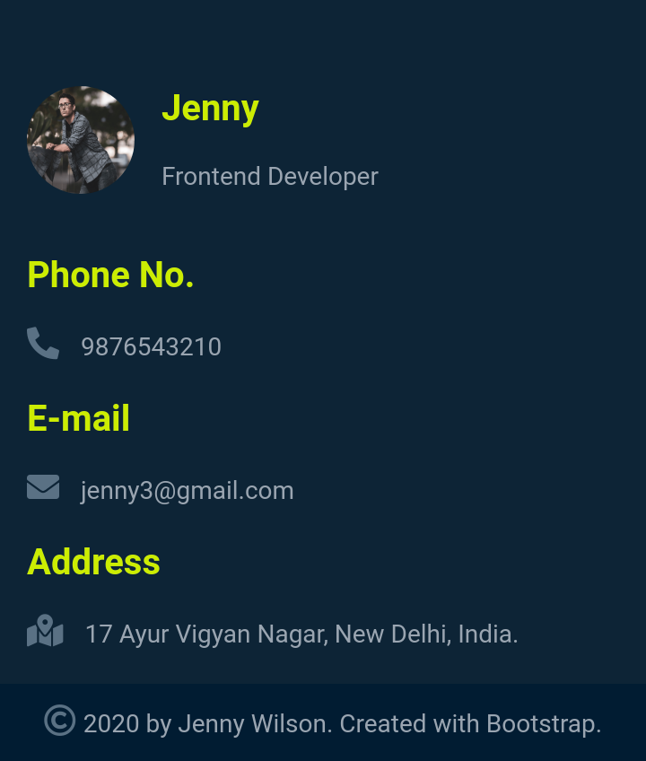

Medium (Size >= 768px), Large (Size >= 992px) and Extra Large (Size >= 1200px):

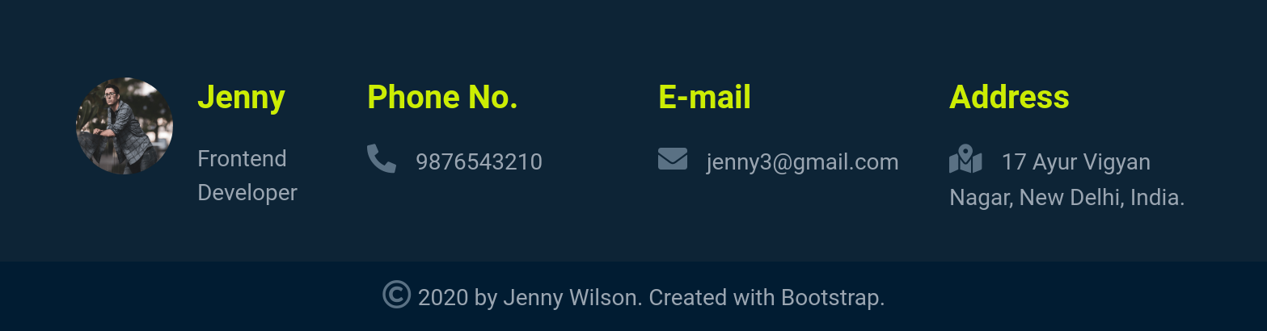

Note

* Try to achieve the design as close as possible.
* The Icons used in this section are Font Awesome Icons.

**Resources**

Use the image URL given below.

* https://d1tgh8fmlzexmh.cloudfront.net/ccbp-responsive-website/portfolio-about-me-img.png

**CSS Colors used:**

#001c32

#cced00

#0d2436

#9aa5b1

#5a7184